Differential Shoreline Dynamics of Inhabited and Uninhabited Estuarine Islands in the Indian Sundarbans (1990–2024)
Anubhav Ghosh
II-M.Tech. Geoinformatics, Department of Geography, University of Madras
Research Intern, Indian Institute of Science (IISc), Bengaluru
Email: anubg2000@gmail.com
Submitted to: 100 Years of Geographical Research in India (eds. Siddiqui, Sarkar & Singh)

Abstract
Rapid relative sea – level rise (RSLR), strong tidal forcing, sediment – supply disturbance and frequent cyclones have severely affected Indian Sundarbans, which is the world’s largest continuous mangrove delta (Hazra et al., 2002; Pethick & Orford, 2013; IPCC, 2021). To understand how human settlement and embankment affect the shoreline behaviour we have chosen a paired island design. (inhabited vs uninhabited). Kumirmari (19.09 km², inhabited–interior), Hamilton (84.94 km², uninhabited–interior), Mousuni (26.19 km², inhabited–coastal) and Lothian (36.30 km², uninhabited–coastal) – these four islands have been chosen. To extract shoreline, Multi-temporal Landsat archive (1990–2024) has been processed in Google Earth Engine (GEE) along with thresholding using MNDWI + Otsu (McFeeters, 1996; Xu, 2006; Otsu, 1979; Gorelick et al., 2017). Using FES2022 global tide model each shoreline is tidally corrected (Lyard et al., 2021; CNES, 2024). Shoreline change was quantified using EPR and LRR along DSAS-equivalent transects (Thieler et al., 2009; Himmelstoss et al., 2018), Cyclone-induced inundation was assessed using Sentinel-1 SAR backscatter (Torres et al., 2012; Lee, 1980). Future shoreline positions (2034, 2044) were projected using a 2-D Kalman filter (Kalman, 1960; Long & Plant, 2012; Vitousek et al., 2017). Results show that the inhabited-coastal islands are the most vulnerable: Mousuni ~72% transect net erosional and the most eroded transect (-24.99 m yr⁻¹) within ~6% of the highest reported Sundarbans–Hooghly erosion rate (~−23.5 m yr⁻¹; Bandyopadhyay, 1997; Gopinath & Seralathan, 2005). Mousuni shows a ~−93 m retreat (~84% transect eroding) according to Kalman forecast of 2044. In contrast, sheltered interior islands exhibit near-stable and statistically indistinguishable shoreline behaviour: Kumirmari (−0.62 m yr⁻¹) and Hamilton (−0.89 m yr⁻¹). Lothian remains stable to slightly accretional (+0.54 m yr⁻¹, LRR +1.44). Habitation and erosion have strong impact in the open coast but in the sheltered interior it is negligible: Island setting × habitation interaction (+2.10 m yr⁻¹, 95% CI [+0.25, +4.08]). These findings have direct implications for coastal management, embankment policy and climate – adaptation planning.
Keywords: Indian Sundarbans, shoreline change, DSAS, EPR, LRR, MNDWI, FES2022 tidal correction, Sentinel-1 SAR, Kalman filter.
1. Introduction
Risk-exposed environment includes Low-lying deltaic coast at global level among all (Syvitski et al., 2009; Ericson et al., 2006; Tessler et al., 2015). Indian and Bangladeshi Sundarbans which are present in Ganga-Bramhaputra-Meghna (GBM) delta is a classic example of such environment. It is affected by multiple factors such as: mangrove ecology, intense human pressure, micro-tidal regime and sediment dynamics (Giri et al., 2011; Ghosh et al., 2015; Woodroffe et al., 2016). The low-lying tropical deltas will be dominantly driven by relative sea-level rise in the 21st Century according to the IPCC AR6 and due to subsidence and sediment-starvation the Sundarbans Region has reported sea level rise which much higher than the global mean (Pethick & Orford, 2013; Hazra et al., 2002). The net result of all these processes is captured by the Shoreline, which acts a geo-indicator (Boak & Turner, 2005; Crowell et al., 1991). In regards to coastal-hazard assessment, climate adaptation and erosion management – the historical movement of the shoreline needs to be quantified. Sagar, Ghoramara, Namkhana and other Hooghly-estuary islands follow a long legacy of shoreline change study in the Indian Sundarbans (Bandyopadhyay, 1997; Gopinath & Seralathan, 2005; Ghosh et al., 2001; Bandyopadhyay et al., 2014; Rahman et al., 2011). However, two critical research gaps remain. First, most studies focus on either a single island or the entire biosphere, failing to systematically isolate how human settlement and engineered embankments alter shoreline behavior. Second, very few study focus on the correction of tidal stage, though apparent change can be there in uncorrected instantaneous waterline in micro-tidal Sundarbans just because of tide (Boak & Turner, 2005; Lyard et al., 2021).
We made a 2×2 factorial deign: two factors – i) Settlement status (inhabited vs uninhabited) and ii) Geomorphic position (interior vs coastal/seaward), each combination is represented by using an island. This design will enable us to find an “interaction” through which we can analyse if the impact of settlement is increasing with coastal exposure or not. In order to come to a robust conclusion, we have employed four remote sensing approaches and integrating them together. (i) GEE-based MNDWI + Otsu shoreline extraction (McFeeters, 1996; Xu, 2006; Otsu, 1979; Gorelick et al., 2017); (ii) for each epoch: FES2022 tidal correction (Lyard et al., 2021; CNES, 2024); (iii) for change rate: DSAS-equivalent transect statistics (EPR, LRR) (Thieler et al., 2009; Himmelstoss et al., 2018; Dolan et al., 1991); and (iv) For shoreline forecasting a 2-D Kalman filter (Long & Plant, 2012; Vitousek et al., 2017). Alongside the Sentinel-1 SAR has been used for observing the cyclone-period (Amphan 2020, Yaas 2021, Remal 2024) inundation/backscatter change (Torres et al., 2012; Lee, 1980).
Three specific objectives are there in this study: (1) To make tidally – corrected shoreline evolution map from the period 1990 – 2024 and measure it. (2) Statistically compering the change-rate between inhabited vs uninhabited and interior vs coastal setting. (3) Mid-century (2034, 2044) shoreline position forecast to identify the most vulnerable point using Kalman filter. Our hypothesis is that the inhabited – coastal setting (Mousuni) will show the maximum rate of erosion because of the following reasons: embankment – induced sediment starvation, tidal – prism disturbance and direct marine exposure all of which act together (Bandyopadhyay, 1997; Pethick & Orford, 2013).
2. Study Area
Figure 1
Study Area and Location of the Four Study Islands in the Indian Sundarbans (South 24 Parganas, West Bengal)
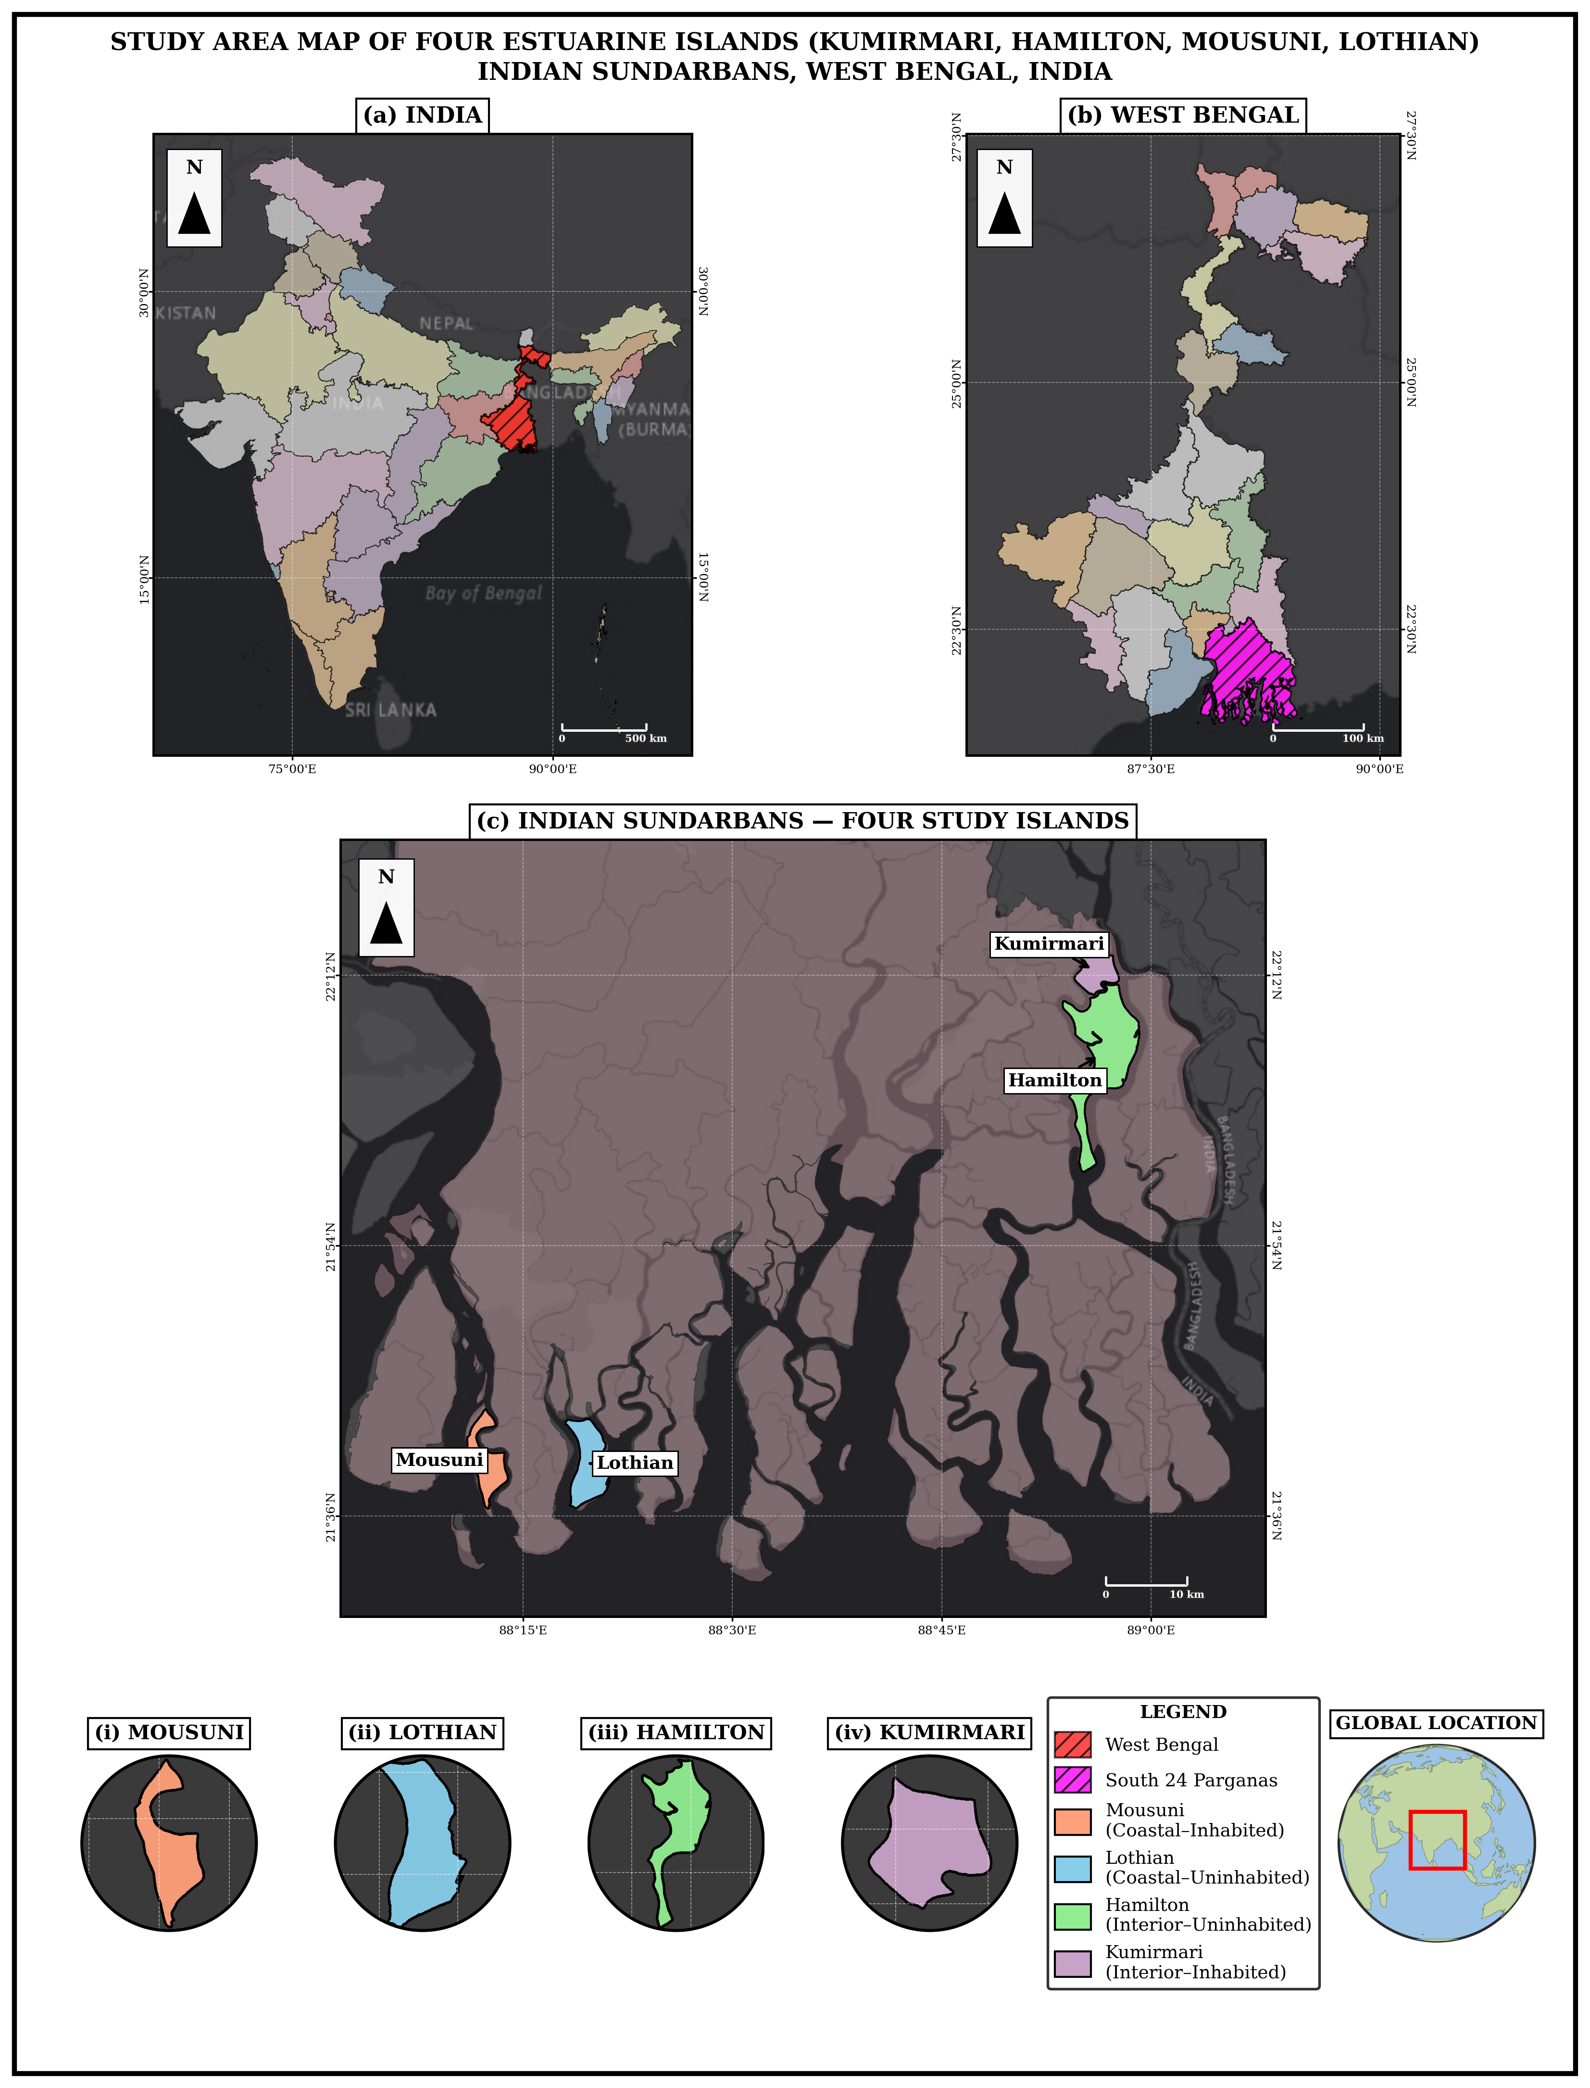
Note. Inset: position within the Ganga–Brahmaputra–Meghna delta. Islands: Kumirmari and Hamilton (interior), Mousuni and Lothian (coastal).
Table 1. Study islands and the 2×2 paired design (areas from the GEE MNDWI 2024 reference).
 | Inhabited (settled, embanked) | Uninhabited (protected)
Interior (estuarine) | Kumirmari — 19.09 km² (Gosaba Block) | Hamilton — 84.94 km²
Coastal (seaward) | Mousuni — 26.19 km² | Lothian — 36.30 km² (Wildlife Sanctuary)

3. Diagram and Methods
Figure 2
Methodological Workflow of the Study
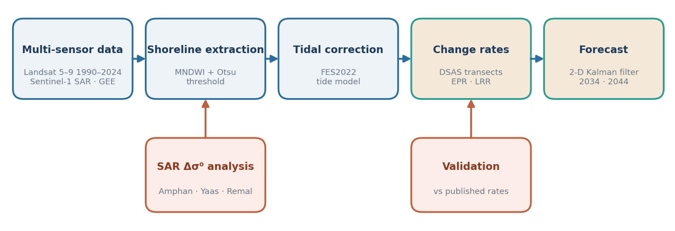
Note. Shoreline has been extracted using MNDWI from Landsat 5,7,8,9 imagery and Otsu thresholding (McFeeters, 1996; Xu, 2006; Otsu, 1979; Gorelick et al., 2017) and it has been tidally corrected using FES2022 ocean-tide model (Lyard et al., 2021; CNES, 2024), in a parallel Sentinel – 1 SAR branch the cyclone – period inundation is captured (Torres et al., 2012; Lee, 1980), Using DSAS-equivalent transect the change rate has been computed (Thieler et al., 2009; Himmelstoss et al., 2018; Dolan et al., 1991) and furthermore the future shoreline has been projected using 2-D Kalman filter (Kalman, 1960; Long & Plant, 2012; Vitousek et al., 2017).
3.1 Satellite data and cloud processing
For optical analysis Landsat Collection – 2 Surface Reflectance archive (Landsat 5 TM, 7 ETM+, 8-9 OLI) has been used which has been accessed and processed in Google Earth Engine (GEE) (Gorelick et al., 2017; Roy et al., 2014; Wulder et al., 2019). Twelve epoch (1990, 1995, 2000, 2005, 2008, 2010, 2013, 2016, 2019, 2020, 2022, 2024) has been chosen so that it covers both the long term and recent cyclone-year. For each epoch, dry-season (pre-monsson) image cloud-mask has been used create median composite in order to minimise residual cloud and sensor-noise. For SAR component, Sentinel-1 GRD (C-band, VV/VH) imagery round the cyclone-window has been used (Torres et al., 2012). Coordinate system for the whole was WGS 84/UTM Zone 45N (EPSG:32645).
3.2 Shoreline extraction: MNDWI + Otsu
To extract Land-water boundary we used only one water index- it’s a formula that combines the satellite bands so that the water can be separated from the land and can be understood separately. The Original index which is NDWI, which uses green and near-infrared (NIR) bands (McFeeters, 1996):
NDWI = (Green − NIR) / (Green + NIR) (1)
The waters of Sundarbans are turbid and full of sediments which leads the NDWI to wrongly flag bright land to water. Therefore, we use modified NDWI (MNDWI) which uses shortwave-infrared (SWIR) band instead of NIR and separates land from water more reliably (Xu, 2006; cf. Gao, 1996):
MNDWI = (Green − SWIR) / (Green + SWIR) (2)
MNDWI in open water is high and in low land it is low. Instead of choosing the Land/water threshold by optical observation, we used Otsu (1979) method which does this automatically.
Otsu uses every possible threshold and divides each pixel into two class (water, land) whose probability is ω₀, ω₁ and mean index value μ₀, μ₁:
ω₀(t) = Σ p(i) for i ≤ t ; ω₁(t) = Σ p(i) for i > t (3)
μ₀(t) = [Σ i·p(i), i ≤ t] / ω₀ ; μ₁(t) = [Σ i·p(i), i > t] / ω₁ (4)
Then, with the help of between class variance it measures how well the classes are separated and the threshold selects t* which makes this separation largest:
σ²_B(t) = ω₀ · ω₁ · (μ₁ − μ₀)² (5)
t* = argmax over t of σ²_B(t) (6)
This works as the total spread of the histogram remains fixed, which is the divided into within class part and between-class part – so maximizing the between -class part is similar to making each class as tight as possible:
σ²_total = σ²_within(t) + σ²_B(t) (7)
We applied Otsu threshold in each MNDWI image, and converted the resulting water-mask boundary to shoreline line (LineString) and calculated NDVI in context of mangrove/vegetation (Tucker, 1979).
Figure 3a
Multi-Temporal MNDWI Composites (1990–2024), Interior Islands (Kumirmari, Hamilton)
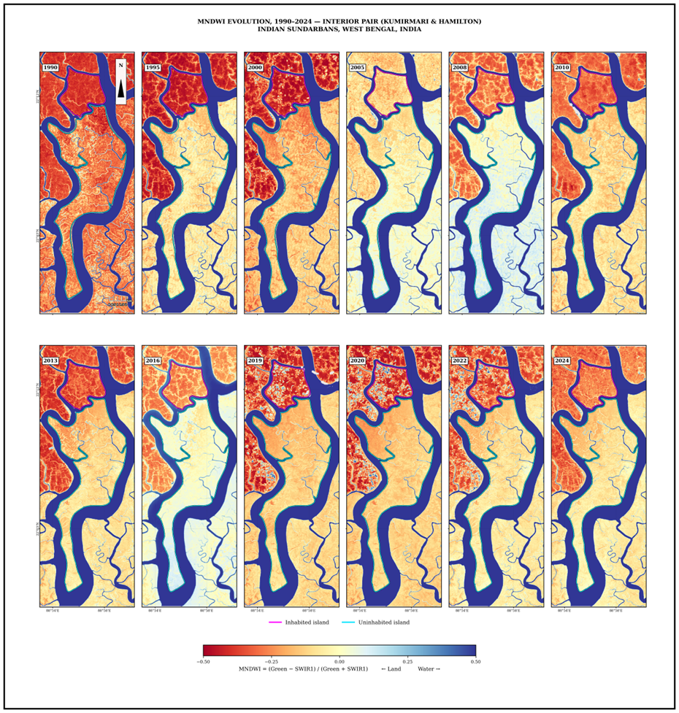
Note. Higher MNDWI = open water; this is the basis for shoreline extraction.

Figure 3b
Multi-Temporal MNDWI Composites (1990–2024), Coastal Islands (Mousuni, Lothian)
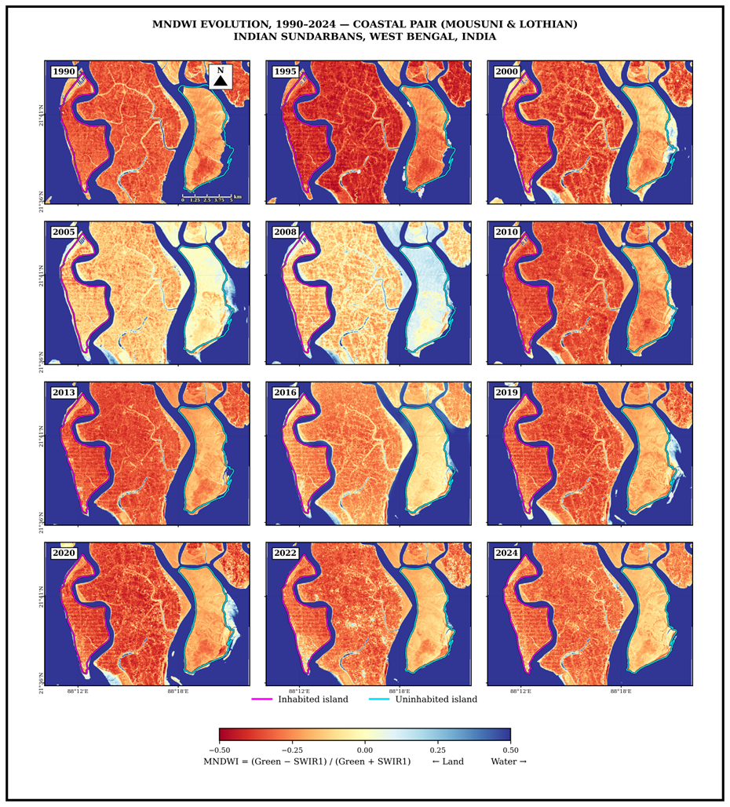
3.3 Tidal correction: FES2022
The Sundarbans experience meso- to macro-tidal conditions, with spring tidal ranges often exceeding 4 m. Because satellite images are acquired at different tidal stages, the observed position of the shoreline can vary substantially between dates. Therefore, shoreline positions extracted from different years cannot be compared directly without correcting for tidal effects (Boak & Turner, 2005). In this study, the FES2022 global ocean tide model was used to estimate the instantaneous tidal height (h) for each satellite image (Lyard et al., 2021; CNES, 2024). The extracted shoreline was then shifted horizontally to a common reference datum. Assuming a simple foreshore geometry, the horizontal displacement of the shoreline can be expressed as:
Δx = (h − h_ref) / tan β (8)
where β represents the foreshore slope. A representative slope value of β ≈ 0.0075 was adopted. Under this assumption, a 2 m difference in tidal height corresponds to an approximate horizontal displacement of 267 m. This magnitude is sufficiently large to influence shoreline-change estimates if tidal correction is not applied. Consequently, tidal normalization was performed before conducting inter-epoch shoreline comparisons.
3.4 SAR backscatter and cyclone analysis
Cyclone brings heavy clouds and rain along with it and optical sensors like Landsat cannot see the land though all these obstructions. Radar (SAR) creates its own signal on its own and can work even through the clouds, whether it is day or night. So, we have selected three recent cyclones - Amphan (May 2020), Yaas (May 2021) and Remal (May 2024) and used Sentinel-1 C-band SAR (Torres et al., 2012; Chakma & Akter, 2021). Smooth water reflects the radar away from the sensor and shows in dark colour, while presence rough land and vegetation scatter it back and look bright, when the land floods then its backscatter (σ⁰, “sigma-naught”) reduces. We have processed the steps in three processes. Firstly, we reduced the grainy speckle noise by Lee filter (Lee, 1980; Lee et al., 1994), which replaces each pixel with a weighted share of local mean plus original detail:
filtered = Ī + W·(I − Ī), with W = 1 − C_u² / C_I² (9)
where, Ī is mean of a small moving window. C_u is noise level and variability of C_I window, in smooth areas W → 0 (noise smoothed away) and at edges W → 1 (detail kept).
Second, we put backscatter on the decibel scale used for radar (Small, 2011):
σ⁰_dB = 10 · log₁₀(σ⁰) (10)
Third, for each cyclone we compared the VV image just after the storm with one just before it:
Δσ⁰ = σ⁰_post − σ⁰_pre (11)
A clear drop (negative Δσ⁰) marks newly water-covered, flooded land – this is the standard SAR change-detection approach for flood mapping (Amitrano et al., 2018; Chakma & Akter, 2021). We used this SAR evidence only in support of optical shoreline results not for replacing it: Sentinel -1 only started around 2014; therefore, it covers the recent cyclones not the long-term (1990-2024) rate. Backscatter is a proxy of drop water, not the direct measurement.

Figure 4a
Sentinel-1 VV Backscatter (σ⁰, dB), Interior Islands
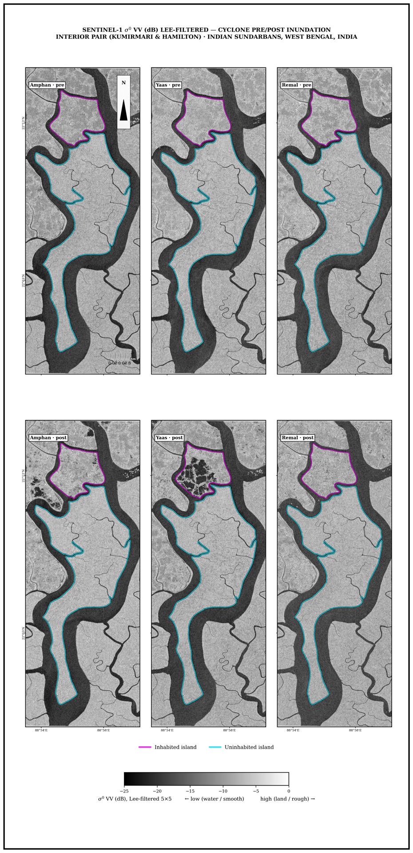
Figure 4b
Sentinel-1 VV Backscatter (σ⁰, dB), Coastal Islands
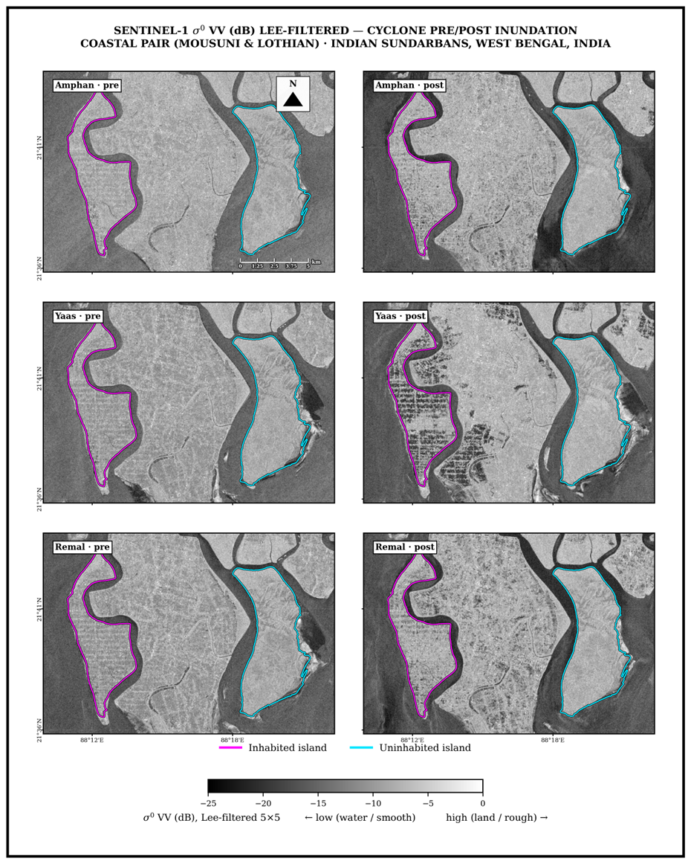
3.5 Change-rate statistics: DSAS-equivalent transects (EPR, LRR)
To change the shoreline with date we used standard transect framework of Digital Shoreline Analysis System (Thieler et al., 2009; Himmelstoss et al., 2018; Bera & Maiti, 2019). Baseline has been set ~200m landward from the coast, shore-perpendicular transect has been cast at a fixed spacing (50 m for the interior islands; comparable for the coastal ones — 352 transects on Kumirmari, 603 on Mousuni, 573 on Lothian, 1377 on Hamilton), and on each transect we calculate that distance (d) where each year’s shoreline crosses it. End-Point Rate uses the oldest and newest shoreline (Dolan et al., 1991):
EPR = (d_new − d_old) / (t_new − t_old) (12)
Linear Regression Rate uses every shoreline - by fitting a least-squares line through all the (t, d) points; its slope is the rate (Crowell et al., 1991; Genz et al., 2007):
LRR = Σ (t_i − t_mean)(d_i − d_mean) / Σ (t_i − t_mean)² (13)
LRR is more robust as one bad year cannot affect it, therefore we take LRR as main trend and EPR as cross check. With every rate there is an uncertainty driven by the positional error U of the shorelines (~35 m coastal, ~50 m interior, combining pixel size, co-registration and residual tidal error); for the end-point rate:
U_EPR = √(U_old² + U_new²) / (t_new − t_old) (14)
A measured rate is treated as real change only when it exceeds this uncertainty. These transect rates are directly comparable with the wider Indian-Sundarbans DSAS literature (Bera & Maiti, 2019; Das et al., 2021).
3.6 Validation against published rates
To check whether our number are sensible or not, we compared the independently published erosion rates of Mousuni Island. Western part of the Indian Sundarbans and Hooghly-estuary have erosion rate of roughly -20 to -24 m yr⁻¹ (Bandyopadhyay, 1997; Gopinath & Seralathan, 2005; Bandyopadhyay et al., 2014), and Mousuni Island reported in a recent DSAS study that extreme erosion rate was around −23.55 m yr⁻¹ in which 90% of the perimeter is eroding (Mishra et al., 2026). We compared mean EPR of our worst 5% (most-eroding) transect with the published figures (Section 4.3). The close agreement is the evidence that MNDWI + FES2022 + DSAS workflow externally valid.
3.7 Future projection: 2-D Kalman filter.
To estimate where each shoreline will be in 2034 and 2044, we used Kalman filter (Kalman, 1960; Long & Plant, 2012; Vitousek et al., 2017). If we extend the LRR directly into the future then each measurement is taken perfectly and no error is found, therefore Kalman filter keeps a running best guess and corrects each time it sees the guess – trusting reliable measurements more and noisy ones less — producing a smoothed rate and a forecast whose uncertainty grows with the horizon. For each transect it tracks tracks the shoreline position y and its rate v as a state x = [y, v], assuming a roughly constant rate, and repeats two steps over 1990–2024. The predict step pushes the guess forward by one time step Δt:
x⁻ = F·x, P⁻ = F·P·F^T + Q, with F = [[1, Δt], [0, 1]] (15)
where p is the guess’s uncertainty and Q is process noise. After this update step guess is corrected using shoreline z H = [1, 0]; R is the measurement error from Section 3.5), through Kalman gain K which balances between model and data:
K = P⁻·H^T / (H·P⁻·H^T + R) (16)
x = x⁻ + K·(z − H·x⁻), P = (I − K·H)·P⁻ (17)
After all the shorelines are assimilated, filter has the present position and a smoothed rate v to forecast it predicts forward with no new data, so the position advances and the uncertainty σ grows with the horizon:
y(t) = y_now + v·(t − t_now), with σ increasing with the horizon (18)
This along-transect movement is placed along the transect azimuth map, so the 2024 → 2034 → 2044 positions are created. The filter is the forecasting tool which is built in DSAS and has been applied the same Bay of Bengal / Meghna delta system as the Sundarbans (Kona et al., 2025). It cannot anticipate sudden non-linear change (embankment breach or future cyclone) therefore forecast is not seen as a exact prediction but studied as a trend-plus-uncertainty.
4. Results
4.1 Tidally-corrected shoreline evolution (1990–2010–2024)
Figure 5 shows the tidally corrected shoreline positions of the four selected islands for the years 1990 (purple), 2010 (teal) and 2024 (yellow). The shoreline change pattern is not same for all the islands and varies according to their geographical setting. In Mousuni Island (inhabited–coastal), the shoreline has gradually shifted towards the landward side during the study period. The position of the 1990 shoreline is much farther seaward compared to the 2024 shoreline, indicating a continuous erosional trend. In contrast, Lothian Island (uninhabited–coastal) exhibits a mixed pattern of shoreline change, where some parts of the island experienced erosion while other parts showed accretion. Kumirmari Island (inhabited–interior) remained comparatively stable throughout the study period. The shoreline positions of 1990, 2010 and 2024 largely overlap with each other, with less than 1 km variation in the total island perimeter of approximately 18 km, suggesting very little net shoreline change. A similar condition is observed in Hamilton Island (uninhabited–interior), which shows only slight erosion. Therefore, based on visual interpretation, the two interior islands exhibit almost similar shoreline characteristics. These observations are also consistent with the quantitative shoreline change rates presented in Section 4.2.
Figure 5
Tidally-corrected shoreline evolution of the four islands. (1990, 2010, 2024)
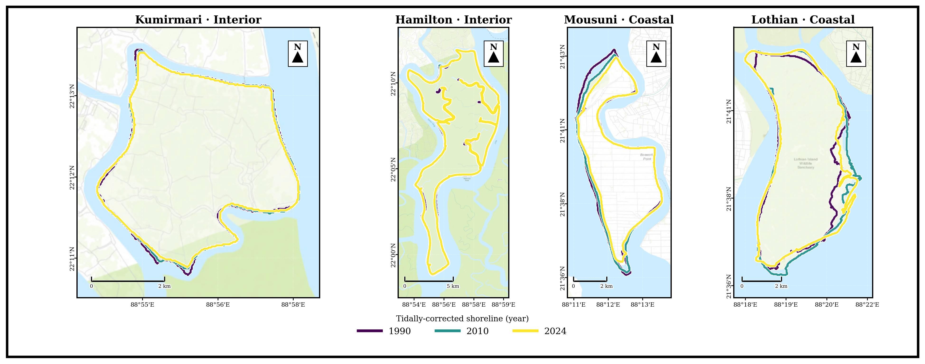
Note. Successive shorelines on Mousuni shift markedly landward (net erosion); the interior pair (Kumirmari, Hamilton) is near-stable and Lothian is broadly stable to weakly accretional.
4.2 Change rates and contrast between inhabited and uninhabited islands
Figure 6 presents the spatial distribution of shoreline change rates derived from the DSAS LRR analysis. The highest erosional rates are mainly concentrated along the north-western coast of Mousuni Island facing the Muriganga estuary. Overall, the results indicate that the effect of habitation on shoreline change varies according to the geomorphic setting of the islands. Among the exposed coastal islands, Mousuni, which is inhabited, experienced considerably higher erosion than the uninhabited island of Lothian. Mousuni recorded a mean EPR of −4.54 m yr⁻¹ and a mean LRR of −4.69 m yr⁻¹, with approximately 72% of the transects showing erosion. In contrast, Lothian recorded a mean EPR of +0.54 m yr⁻¹ and a mean LRR of +1.44 m yr⁻¹, while nearly 50% of its transects showed accretion. Statistical analysis using both the Mann–Whitney and Kolmogorov–Smirnov tests confirmed that the shoreline change distributions of these two coastal islands are significantly different (p < 0.001). However, the erosion pattern of Mousuni is not uniform. The mean erosion rate is strongly influenced by a small number of transects with very high erosion values, which is reflected by the difference between the median EPR (−1.36 m yr⁻¹) and the mean EPR (−4.54 m yr⁻¹). A different pattern is observed in the sheltered interior islands. Kumirmari, the inhabited interior island, recorded a mean EPR of −0.62 m yr⁻¹ and a mean LRR of −0.85 m yr⁻¹, with 54% of transects showing erosion and 35% remaining relatively stable. Similarly, the uninhabited island of Hamilton recorded a mean EPR of −0.89 m yr⁻¹ and a mean LRR of −0.95 m yr⁻¹, with about 65% of transects experiencing erosion. The difference between these two interior islands is relatively small (+0.29 m yr⁻¹), and the block-bootstrap 95% confidence interval (−0.01 to +0.75 m yr⁻¹) suggests that this difference is not statistically significant. The difference-of-differences analysis further highlights the importance of island setting. The interaction effect between habitation status and island setting was estimated to be +2.10 m yr⁻¹ (95% CI: +0.25 to +4.08 m yr⁻¹), and this result was statistically significant. This suggests that the influence of habitation and embankment construction on shoreline erosion is more evident along the exposed coastal environment, whereas such an effect is not clearly visible within the low-energy interior setting. It is also noteworthy that the two uninhabited islands, Hamilton and Lothian, do not differ significantly from each other. This control comparison supports the interpretation that the stronger erosional response observed in the inhabited coastal setting is likely associated with anthropogenic modification in addition to natural processes (cf. Bandyopadhyay, 1997; Pethick & Orford, 2013; Bera & Maiti, 2019).
Figure 6
DSAS Linear Regression Rate (LRR) Across Transects for All Islands
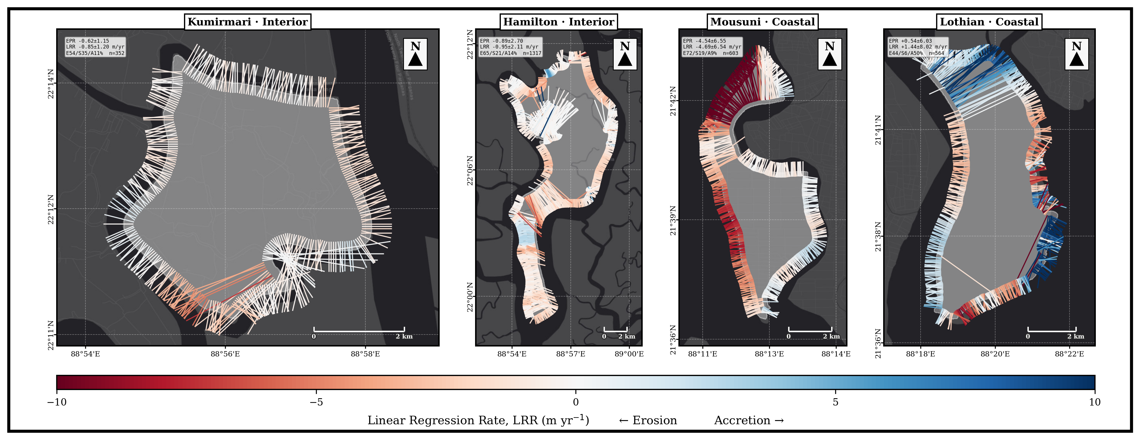
Note. Red = erosion, blue = accretion; the NW sector of Mousuni is the most erosional.
The per-island mean change rates are summarised in Figure 7.
Figure 7
Mean Shoreline-Change Rates by Island, 1990–2024: End-Point Rate (EPR) and Linear Regression Rate (LRR), Grouped by Exposure Setting and Coloured by Settlement Regime
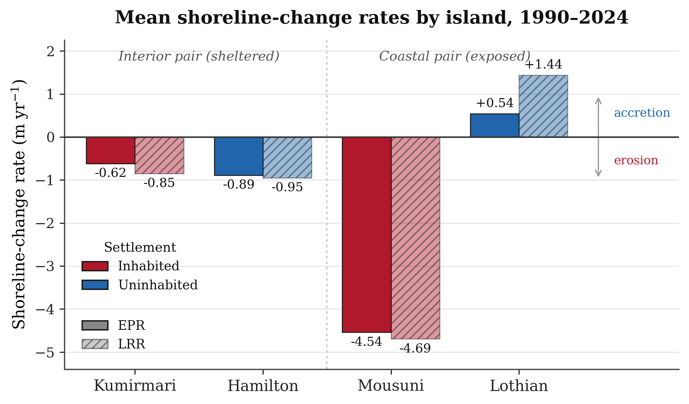
Note. The two estimators agree closely; strong erosion is confined to the exposed inhabited island (Mousuni), while the sheltered interior pair is near-stable and the exposed uninhabited island (Lothian) accretes (Thieler et al., 2009; Himmelstoss et al., 2018).
4.3 Validation of shoreline change rates in Mousuni Island
To evaluate the reliability of the present analysis, the transect-wise EPR values obtained for Mousuni Island were compared with shoreline change rates reported in previous studies. The distribution of EPR values is dominated by negative values, indicating that erosion is the principal shoreline process operating in the island. The median EPR value was −1.36 m yr⁻¹, whereas the mean EPR was −4.54 m yr⁻¹, suggesting the presence of a few transects with exceptionally high erosion rates. The maximum erosion rate recorded in this study was −24.99 m yr⁻¹ and occurred along the north-western coast facing the Muriganga estuary (approximately azimuth 332°). This value is very similar to the maximum erosion rates reported from the Sundarbans and Hooghly estuarine region by earlier studies (approximately −23.5 m yr⁻¹; Bandyopadhyay, 1997; Gopinath & Seralathan, 2005). The close agreement between the present and published values suggests that the shoreline extraction and change analysis methods used in this study provide realistic estimates of shoreline behaviour.
4.4 Backscatter response during major cyclone events
The Sentinel-1 backscatter coefficient (σ⁰, dB) showed a noticeable decrease during the post-cyclone periods following Amphan (2020), Yaas (2021) and Remal (2024). Such reductions in backscatter are generally associated with temporary inundation and the presence of standing water (Torres et al., 2012; Lee, 1980). The decrease in backscatter was more pronounced in the coastal islands, namely Mousuni and Lothian, than in the interior islands. This observation is expected because the coastal islands are more directly exposed to storm surge and marine forcing processes (Hazra et al., 2002; IPCC, 2021). Therefore, the SAR observations support the shoreline changes observed from optical satellite imagery and provide additional evidence for the role of extreme cyclone events in shaping long-term shoreline dynamics.
Figure 8a
Cyclone-Period Sentinel-1 Backscatter (Interior Islands) Around Amphan, Yaas and Remal
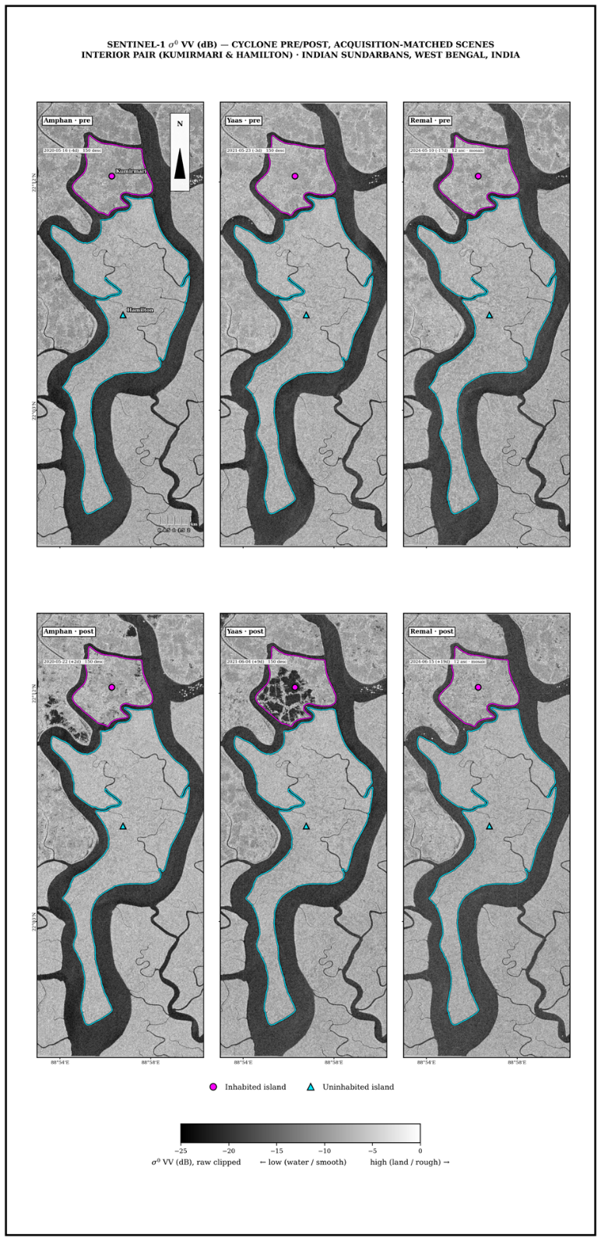
Figure 8b
Cyclone-Period Sentinel-1 Backscatter (Coastal Islands)
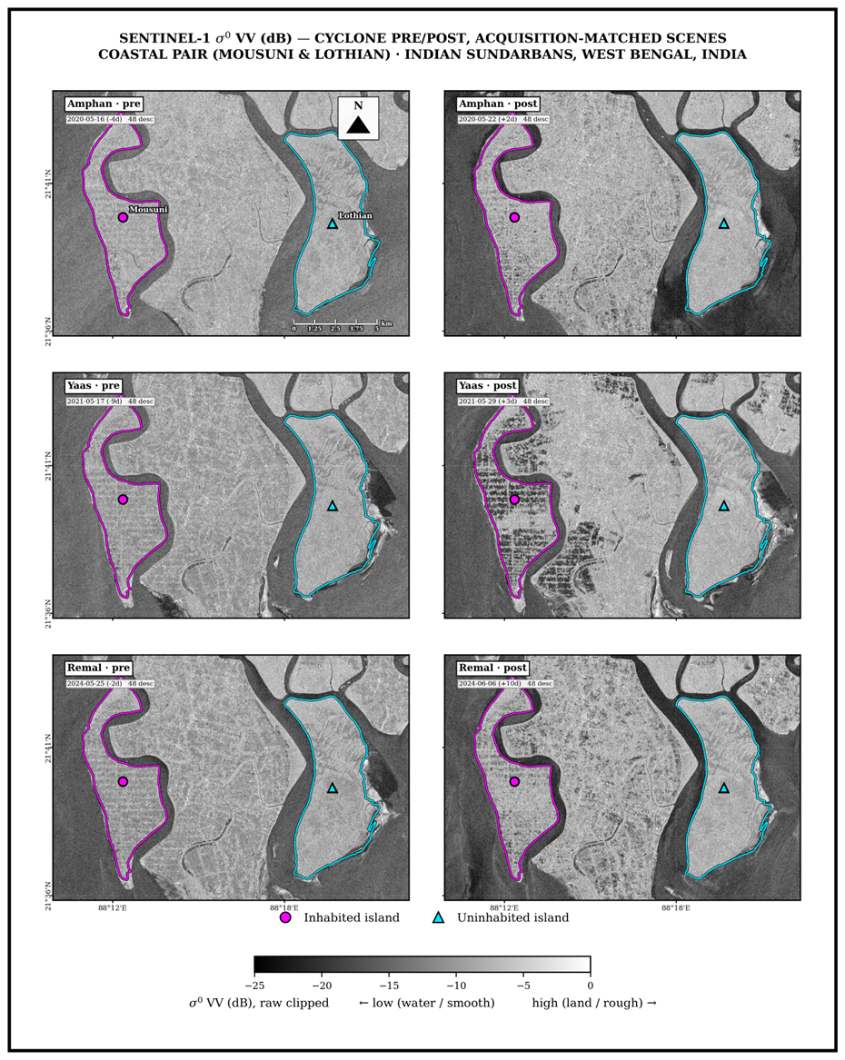
Note. A post-event σ⁰ drop = temporary inundation.
4.5 Kalman-filter shoreline forecasts for 2034 and 2044
The shoreline forecasts generated using the Kalman filter model (Figure 9) suggest that the present differences between coastal and interior islands are likely to continue in the future. Among the four islands, Mousuni is projected to experience the greatest shoreline retreat. By 2044, the projected mean shoreline change is approximately −93 m (±123 m), and around 84% of the transects are expected to remain erosional. This indicates that Mousuni is likely to remain the most vulnerable island in the study area. The interior islands also show continued retreat, although the magnitude of change is considerably smaller. Kumirmari is projected to undergo a mean retreat of approximately −16 m (±23 m), whereas Hamilton is projected to retreat by approximately −19 m (±38 m). In both islands, nearly 81% of the transects are expected to remain erosional. In contrast, the uninhabited coastal island of Lothian is projected to remain relatively stable on average, with a mean shoreline change of about +12 m (±161 m), although nearly half of its transects may still experience erosion. The large variability associated with Lothian reflects differences in shoreline behaviour across various parts of the island. A similar pattern is observed in the 2034 projections, where Mousuni shows the highest retreat (~−44 m), followed by Hamilton (~−9 m), Kumirmari (~−8 m) and Lothian (~+5 m). These projections should be considered as possible future shoreline scenarios with associated uncertainty rather than exact predictions (Long & Plant, 2012; Vitousek et al., 2017).
Figure 9
Kalman-filter shoreline forecast (position per transect) for the four islands up to 2034 and 2044.
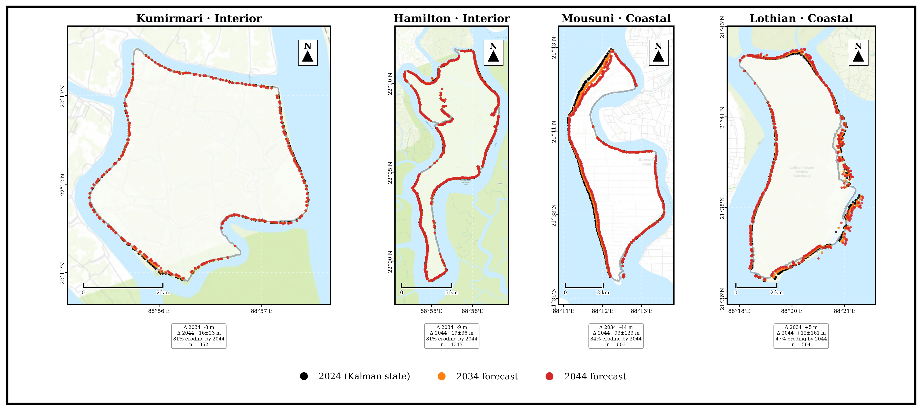
Note: Mousuni shows the most significant projected retreat, interior islands (Kumirmari, Hamilton) show moderate retreat, and Lothian appears near-stable yet highly variable.
The projected shoreline trajectories up to 2044 follow the same regime contrasts across all four islands.
5. Discussion
The results obtained in this study suggest that shoreline change in the Indian Sundarbans is controlled not only by natural processes but also by human activities and engineering interventions. The paired-island analysis showed that the inhabited coastal island, Mousuni, is the most vulnerable among the four selected islands. The results also indicate that the effect of habitation on shoreline change is not the same in all environmental settings. The interaction between island setting and habitation status was found to be statistically significant (+2.10 m yr⁻¹, 95% CI: +0.25 to +4.08). Among the exposed coastal islands, Mousuni experienced much higher erosion than the uninhabited island of Lothian. In contrast, within the sheltered interior environment, the inhabited island of Kumirmari and the uninhabited island of Hamilton showed similar shoreline behaviour. Similarly, no significant difference was observed between the two uninhabited islands. These observations suggest that human intervention, especially embankment construction and settlement development, may enhance shoreline erosion mainly in exposed coastal environments rather than in sheltered estuarine settings (Bandyopadhyay, 1997; Pethick & Orford, 2013). The observed pattern is likely controlled by a combination of factors. One important factor is regional relative sea-level rise and land subsidence, which contribute to landward shoreline migration (Hazra et al., 2002; Rahman et al., 2011; IPCC, 2021). Another important factor is embankment construction, which restricts natural tidal flooding and sediment deposition within the island interiors. This process may lead to sediment starvation and reduce vertical accretion (Pethick & Orford, 2013; Woodroffe et al., 2016). In addition, land reclamation and channel modification can alter estuarine hydrodynamics and increase bank erosion (Bandyopadhyay, 1997; Gopinath & Seralathan, 2005). Extreme cyclonic events such as Amphan, Yaas and Remal also play an important role by producing short-term but severe erosion and inundation, which was observed through the Sentinel-1 backscatter analysis conducted in this study (Torres et al., 2012). The results obtained in this study are similar to those reported in earlier studies from the Sundarbans region. The erosion rates observed in Mousuni Island are comparable with those reported from Sagar Island and other parts of the western Sundarbans, where erosion rates of approximately −20 to −24 m yr⁻¹ have been documented (Bandyopadhyay, 1997; Gopinath & Seralathan, 2005; Bandyopadhyay et al., 2014). In addition, the maximum erosion rate estimated in this study differs by less than 6% from previously published values, which increases confidence in the adopted methodology. The severe erosion observed in inhabited coastal Mousuni, the relatively stable condition of uninhabited coastal Lothian, and the similar behaviour of the two interior islands together suggest that shoreline change is influenced by the combined effect of habitation and coastal exposure rather than by habitation alone (Bera & Maiti, 2019; Ghosh et al., 2015). The methods used in this study have some important advantages. The use of FES2022 tidal correction is particularly important for the macro-tidal environment of the Sundarbans and has not been incorporated in many earlier studies (Lyard et al., 2021; CNES, 2024; Boak & Turner, 2005). The combination of optical and SAR datasets allowed both long-term trends and event-scale processes to be analysed. The Google Earth Engine-based workflow also improved reproducibility and processing efficiency (Gorelick et al., 2017). In addition, the Kalman filter approach enabled uncertainty to be incorporated into future shoreline projections (Long & Plant, 2012). However, some limitations should also be considered. The shoreline extraction was constrained by the spatial resolution of Landsat imagery (~30 m). The tidal correction method assumed a single representative foreshore slope (β ≈ 0.0075), although actual foreshore slopes vary spatially. The constant-velocity Kalman model may not fully represent abrupt or non-linear shoreline changes, such as those caused by embankment breaches. Furthermore, only one island was selected for each environmental setting. Future studies should include a larger number of islands to improve regional generalisation (Genz et al., 2007).
6. Conclusion
The present study used a multi-sensor and tidally corrected framework to analyse shoreline dynamics in four selected islands of the Indian Sundarbans during the period 1990–2024. The results of this study lead to three main conclusions. First, shoreline change in the study area is strongly dependent on island setting. Among the four islands, the inhabited coastal island of Mousuni experienced the highest level of erosion, with approximately 72% of the transects showing erosion, a mean EPR of −4.54 m yr⁻¹, and a maximum erosion rate of −24.99 m yr⁻¹. In contrast, the uninhabited coastal island of Lothian remained relatively stable to slightly accretional. The two interior islands, namely Kumirmari (−0.62 m yr⁻¹) and Hamilton (−0.89 m yr⁻¹), showed similar shoreline behaviour and were not statistically different from each other. Second, the interaction between island setting and habitation status was statistically significant (+2.10 m yr⁻¹, 95% CI: +0.25 to +4.08). This result suggests that habitation and embankment construction are associated with increased erosion mainly in exposed coastal environments, whereas such effects are not clearly visible in sheltered interior environments. Therefore, shoreline erosion in the Sundarbans appears to be influenced by the combined effect of human activities and coastal exposure rather than by habitation alone. Third, the Kalman filter projections indicate that the present differences between the islands are likely to continue in the future. By 2034 and 2044, inhabited coastal islands such as Mousuni are expected to remain highly vulnerable and may require priority adaptation and management measures. The agreement between the present results and previously published shoreline change rates, together with the SAR-based cyclone analysis, further supports the reliability of the findings. From the viewpoint of coastal management, the results suggest that future embankment and shoreline management strategies should consider sediment transport and tidal processes more carefully. Greater priority should also be given to highly vulnerable inhabited coastal islands (Pethick & Orford, 2013; IPCC, 2019, 2021). Future studies may improve these findings by using higher-resolution satellite imagery, spatially variable foreshore slopes, and a larger number of study islands.
References
Amitrano, D., Di Martino, G., Iodice, A., Riccio, D., & Ruello, G. (2018). Unsupervised rapid flood mapping using Sentinel-1 GRD SAR images. IEEE Transactions on Geoscience and Remote Sensing, 56(6), 3290–3299. https://doi.org/10.1109/TGRS.2018.2797536
Bandyopadhyay, J., Mondal, I., & Samanta, N. (2014). Shore line shifting of Namkhana Island of Indian Sundarban, South 24 Parganas, West Bengal. International Journal of Engineering Sciences & Research Technology, 3(5), 162–169.
Bandyopadhyay, S. (1997). Coastal erosion and its management in Sagar Island, West Bengal, India. Indian Journal of Earth Sciences, 24(3–4), 51–69.
Bera, R., & Maiti, R. (2019). Quantitative analysis of erosion and accretion (1975–2017) using DSAS — A study on Indian Sundarbans. Regional Studies in Marine Science, 28, 100583. https://doi.org/10.1016/j.rsma.2019.100583
Boak, E. H., & Turner, I. L. (2005). Shoreline definition and detection: A review. Journal of Coastal Research, 21(4), 688–703. https://doi.org/10.2112/03-0071.1
Chakma, S., & Akter, M. (2021). Flood mapping in the coastal region of Bangladesh during super cyclone Amphan. Journal of the Civil Engineering Forum, 7(3), 267–278. https://doi.org/10.22146/jcef.64497
CNES. (2024). FES2022 (Finite Element Solution) ocean tide (Version 2022) [Data set]. Centre National d'Études Spatiales. https://doi.org/10.24400/527896/A01-2024.004
Crowell, M., Leatherman, S. P., & Buckley, M. K. (1991). Historical shoreline change: Error analysis and mapping accuracy. Journal of Coastal Research, 7(3), 839–852. https://www.jstor.org/stable/4297899
Das, S. K., Sajan, B., Ojha, C., & Soren, S. (2021). Shoreline change behavior study of Jambudwip island of Indian Sundarban using DSAS model. The Egyptian Journal of Remote Sensing and Space Science, 24(3), 961–970. https://doi.org/10.1016/j.ejrs.2021.09.004
Dolan, R., Fenster, M. S., & Holme, S. J. (1991). Temporal analysis of shoreline recession and accretion. Journal of Coastal Research, 7(3), 723–744. https://www.jstor.org/stable/4297888
Ericson, J. P., Vörösmarty, C. J., Dingman, S. L., Ward, L. G., & Meybeck, M. (2006). Effective sea-level rise and deltas: Causes of change and human dimension implications. Global and Planetary Change, 50(1–2), 63–82. https://doi.org/10.1016/j.gloplacha.2005.07.004
Gao, B.-C. (1996). NDWI — A normalized difference water index for remote sensing of vegetation liquid water from space. Remote Sensing of Environment, 58(3), 257–266. https://doi.org/10.1016/S0034-4257(96)00067-3
Genz, A. S., Fletcher, C. H., Dunn, R. A., Frazer, L. N., & Rooney, J. J. (2007). The predictive accuracy of shoreline change rate methods and alongshore beach variation on Maui, Hawaii. Journal of Coastal Research, 23(1), 87–105. https://doi.org/10.2112/05-0521.1
Ghosh, A., Schmidt, S., Fickert, T., & Nüsser, M. (2015). The Indian Sundarban mangrove forests: History, utilization, conservation strategies and local perception. Diversity, 7(2), 149–169. https://doi.org/10.3390/d7020149
Ghosh, T., Bhandari, G., & Hazra, S. (2001, November 5–9). Assessment of land use/land cover dynamics and shoreline changes of Sagar Island through remote sensing [Paper presentation]. 22nd Asian Conference on Remote Sensing, Singapore.
Giri, C., Ochieng, E., Tieszen, L. L., Zhu, Z., Singh, A., Loveland, T., Masek, J., & Duke, N. (2011). Status and distribution of mangrove forests of the world using earth observation satellite data. Global Ecology and Biogeography, 20(1), 154–159. https://doi.org/10.1111/j.1466-8238.2010.00584.x
Gopinath, G., & Seralathan, P. (2005). Rapid erosion of the coast of Sagar Island, West Bengal, India. Environmental Geology, 48(8), 1058–1067. https://doi.org/10.1007/s00254-005-0044-9
Gorelick, N., Hancher, M., Dixon, M., Ilyushchenko, S., Thau, D., & Moore, R. (2017). Google Earth Engine: Planetary-scale geospatial analysis for everyone. Remote Sensing of Environment, 202, 18–27. https://doi.org/10.1016/j.rse.2017.06.031
Hazra, S., Ghosh, T., DasGupta, R., & Sen, G. (2002). Sea level and associated changes in the Sundarbans. Science and Culture, 68(9–12), 309–321.
Himmelstoss, E. A., Henderson, R. E., Kratzmann, M. G., & Farris, A. S. (2018). Digital Shoreline Analysis System (DSAS) version 5.0 user guide (Open-File Report 2018-1179). U.S. Geological Survey. https://doi.org/10.3133/ofr20181179
Intergovernmental Panel on Climate Change. (2019). IPCC special report on the ocean and cryosphere in a changing climate (H.-O. Pörtner, D. C. Roberts, V. Masson-Delmotte, P. Zhai, M. Tignor, E. Poloczanska, K. Mintenbeck, A. Alegría, M. Nicolai, A. Okem, J. Petzold, B. Rama, & N. M. Weyer, Eds.). Cambridge University Press. https://doi.org/10.1017/9781009157964
Intergovernmental Panel on Climate Change. (2021). Climate change 2021: The physical science basis. Contribution of Working Group I to the Sixth Assessment Report of the Intergovernmental Panel on Climate Change (V. Masson-Delmotte, P. Zhai, A. Pirani, S. L. Connors, C. Péan, S. Berger, N. Caud, Y. Chen, L. Goldfarb, M. I. Gomis, M. Huang, K. Leitzell, E. Lonnoy, J. B. R. Matthews, T. K. Maycock, T. Waterfield, O. Yelekçi, R. Yu, & B. Zhou, Eds.). Cambridge University Press. https://doi.org/10.1017/9781009157896
Kalman, R. E. (1960). A new approach to linear filtering and prediction problems. Journal of Basic Engineering, 82(1), 35–45. https://doi.org/10.1115/1.3662552
Kona, A. D., Hoque, M. E., & Rahman, M. A. (2025). Evaluating shoreline prediction accuracy with the Kalman filter model: A case study of Nijhum Dwip, Bay of Bengal. Remote Sensing Applications: Society and Environment, 37, 101469. https://doi.org/10.1016/j.rsase.2025.101469
Lee, J.-S. (1980). Digital image enhancement and noise filtering by use of local statistics. IEEE Transactions on Pattern Analysis and Machine Intelligence, PAMI-2(2), 165–168. https://doi.org/10.1109/TPAMI.1980.4766994
Lee, J.-S., Jurkevich, I., Dewaele, P., Wambacq, P., & Oosterlinck, A. (1994). Speckle filtering of synthetic aperture radar images: A review. Remote Sensing Reviews, 8(4), 313–340. https://doi.org/10.1080/02757259409532206
Long, J. W., & Plant, N. G. (2012). Extended Kalman Filter framework for forecasting shoreline evolution. Geophysical Research Letters, 39(13), L13603. https://doi.org/10.1029/2012GL052180
Lyard, F. H., Allain, D. J., Cancet, M., Carrère, L., & Picot, N. (2021). FES2014 global ocean tide atlas: Design and performance. Ocean Science, 17(3), 615–649. https://doi.org/10.5194/os-17-615-2021
McFeeters, S. K. (1996). The use of the Normalized Difference Water Index (NDWI) in the delineation of open water features. International Journal of Remote Sensing, 17(7), 1425–1432. https://doi.org/10.1080/01431169608948714
Mishra, M., Zerouali, B., Paul, S., Bhattacharyya, D., Guria, R., Suna, M., da Silva, R. M., Ranagalage, M., & Santos, C. A. G. (2026). Coastal futures at risk: Adaptive coastal management and policy insights from sea-level rise and shoreline change in West Bengal, India. Science of the Total Environment, 1014, 181238. https://doi.org/10.1016/j.scitotenv.2025.181238
Otsu, N. (1979). A threshold selection method from gray-level histograms. IEEE Transactions on Systems, Man, and Cybernetics, 9(1), 62–66. https://doi.org/10.1109/TSMC.1979.4310076
Pethick, J., & Orford, J. D. (2013). Rapid rise in effective sea-level in southwest Bangladesh: Its causes and contemporary rates. Global and Planetary Change, 111, 237–245. https://doi.org/10.1016/j.gloplacha.2013.09.019
Rahman, A. F., Dragoni, D., & El-Masri, B. (2011). Response of the Sundarbans coastline to sea level rise and decreased sediment flow: A remote sensing assessment. Remote Sensing of Environment, 115(12), 3121–3128. https://doi.org/10.1016/j.rse.2011.06.019
Roy, D. P., Wulder, M. A., Loveland, T. R., Woodcock, C. E., Allen, R. G., Anderson, M. C., Helder, D., Irons, J. R., Johnson, D. M., Kennedy, R., Scambos, T. A., Schaaf, C. B., Schott, J. R., Sheng, Y., Vermote, E. F., Belward, A. S., Bindschadler, R., Cohen, W. B., Gao, F., … Zhu, Z. (2014). Landsat-8: Science and product vision for terrestrial global change research. Remote Sensing of Environment, 145, 154–172. https://doi.org/10.1016/j.rse.2014.02.001
Small, D. (2011). Flattening gamma: Radiometric terrain correction for SAR imagery. IEEE Transactions on Geoscience and Remote Sensing, 49(8), 3081–3093. https://doi.org/10.1109/TGRS.2011.2120616
Syvitski, J. P. M., Kettner, A. J., Overeem, I., Hutton, E. W. H., Hannon, M. T., Brakenridge, G. R., Day, J., Vörösmarty, C., Saito, Y., Giosan, L., & Nicholls, R. J. (2009). Sinking deltas due to human activities. Nature Geoscience, 2(10), 681–686. https://doi.org/10.1038/ngeo629
Tessler, Z. D., Vörösmarty, C. J., Grossberg, M., Gladkova, I., Aizenman, H., Syvitski, J. P. M., & Foufoula-Georgiou, E. (2015). Profiling risk and sustainability in coastal deltas of the world. Science, 349(6248), 638–643. https://doi.org/10.1126/science.aab3574
Thieler, E. R., Himmelstoss, E. A., Zichichi, J. L., & Ergul, A. (2009). The Digital Shoreline Analysis System (DSAS) version 4.0 — An ArcGIS extension for calculating shoreline change (Open-File Report 2008-1278). U.S. Geological Survey. https://doi.org/10.3133/ofr20081278
Torres, R., Snoeij, P., Geudtner, D., Bibby, D., Davidson, M., Attema, E., Potin, P., Rommen, B., Floury, N., Brown, M., Navas Traver, I., Deghaye, P., Duesmann, B., Rosich, B., Miranda, N., Bruno, C., L'Abbate, M., Croci, R., Pietropaolo, A., … Rostan, F. (2012). GMES Sentinel-1 mission. Remote Sensing of Environment, 120, 9–24. https://doi.org/10.1016/j.rse.2011.05.028
Tucker, C. J. (1979). Red and photographic infrared linear combinations for monitoring vegetation. Remote Sensing of Environment, 8(2), 127–150. https://doi.org/10.1016/0034-4257(79)90013-0
Vitousek, S., Barnard, P. L., Limber, P., Erikson, L., & Cole, B. (2017). A model integrating longshore and cross-shore processes for predicting long-term shoreline response to climate change. Journal of Geophysical Research: Earth Surface, 122(4), 782–806. https://doi.org/10.1002/2016JF004065
Woodroffe, C. D., Rogers, K., McKee, K. L., Lovelock, C. E., Mendelssohn, I. A., & Saintilan, N. (2016). Mangrove sedimentation and response to relative sea-level rise. Annual Review of Marine Science, 8, 243–266. https://doi.org/10.1146/annurev-marine-122414-034025
Wulder, M. A., Loveland, T. R., Roy, D. P., Crawford, C. J., Masek, J. G., Woodcock, C. E., Allen, R. G., Anderson, M. C., Belward, A. S., Cohen, W. B., Dwyer, J., Erb, A., Gao, F., Griffiths, P., Helder, D., Hermosilla, T., Hipple, J. D., Hostert, P., Hughes, M. J., … Zhu, Z. (2019). Current status of Landsat program, science, and applications. Remote Sensing of Environment, 225, 127–147. https://doi.org/10.1016/j.rse.2019.02.015
Xu, H. (2006). Modification of normalised difference water index (MNDWI) to enhance open water features in remotely sensed imagery. International Journal of Remote Sensing, 27(14), 3025–3033. https://doi.org/10.1080/01431160600589179

